**DAILY ONLINE ACTIVITIES SUMMARY**

|  |  |  |  |  |  |  |  |  |
| --- | --- | --- | --- | --- | --- | --- | --- | --- |
| **Date:** | **26-06-2020** | | | | | **Name:** | **IJAZ IBRAHIM** | |
| **Sem & Sec** | **4th A** | | | | | **USN:** | **4AL18CS026** | |
| **Online Test Summary** | | | | | | | | |
| **Subject** | | | **N/A** | | | | | |
| **Max. Marks** | | | **N/A** | **Score** | | | **N/A** | |
| **Certification Course Summary** | | | | | | | | |
| **Course** | **Python Programming for Beginners in Data Science** | | | | | | | |
| **Certificate Provider** | | **Udemy** | | | **Duration** | | | **14 hours** |
| **Coding Challenges** | | | | | | | | |
| **Problem Statement: 1 Python program.** | | | | | | | | |
| **Status: Executed** | | | | | | | | |
| **Uploaded the report in Github** | | | | | **Yes** | | | |
| **If yes Repository name** | | | | | **https://github.com/ijazibrahim/DailyReport.git** | | | |
| **Uploaded the report in slack** | | | | | **Yes** | | | |

Online Test Details: (Attach the snapshot and briefly write the report for the same)

No online exam was conducted today.

Certification Course Details: (Attach the snapshot and briefly write the report for the same)

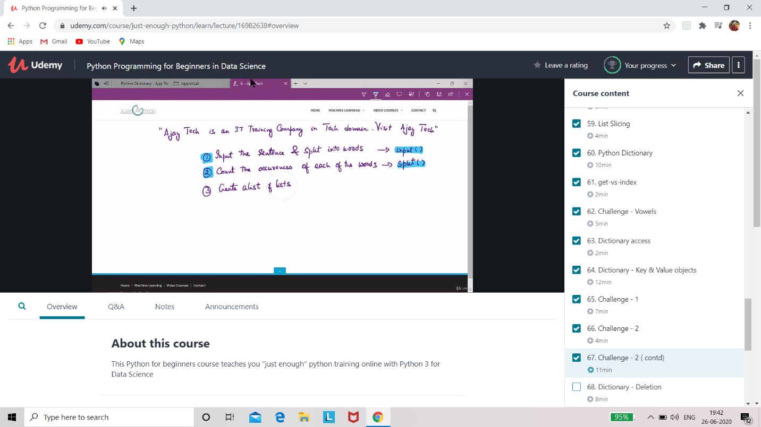

I have Completed 9 hour of the course out of 14 hours and uploaded it in Github repository.

Coding Challenges Details: (Attach the snapshot and briefly write the report for the same)

Program 1:

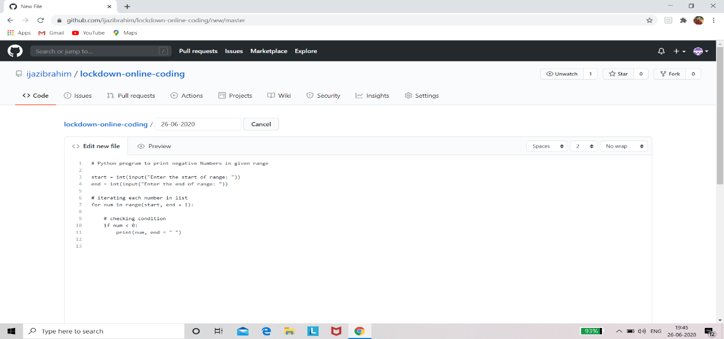

EXTRA ACTIVITIES:

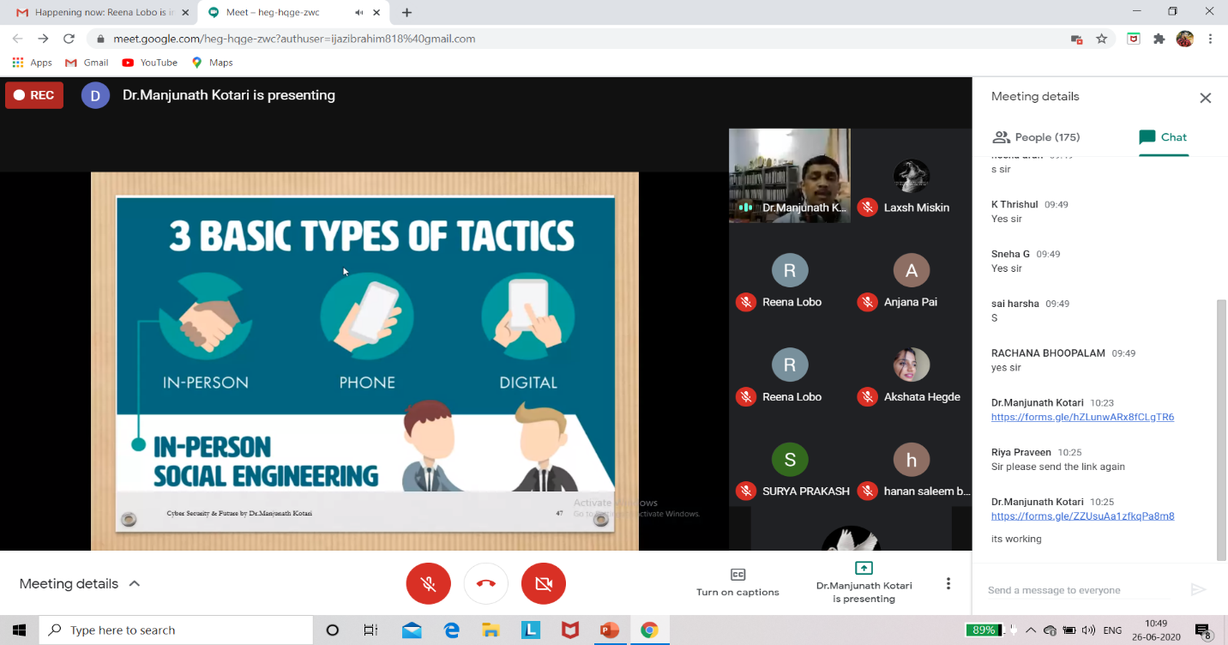

Today I had attended the online training organized by CSE Department AIET. The training was on Cyber security and Feature done by prof. Manjunath kotari HOD of CSE Dept. After the session the quiz was conducted.

This is the snapshot of the quiz attempted and obtained marks

